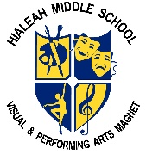
HIALEAH MIDDLE SCHOOL
SCHOOL CLOSURE STUDENT CHECKLIST
Student’s Name__________________________________________ Student ID#__________________
 | Period 1  Teacher  _____________  Subject:  _____________ | Period 2  Teacher  _____________  Subject:  _____________ | Period 3  Teacher  _____________  Subject:  _____________ | Period 4  Teacher  _____________  Subject:  _____________ | Period 5  Teacher  _____________  Subject:  _____________ | Period 6  Teacher  _____________  Subject:  _____________ | Period 7  Teacher  _____________  Subject:  _____________ | Period 8  Teacher  _____________  Subject:  _____________
What tool is my teacher using to communicate with me?
(Canvas, Class DoJo, Class Flow, Edmodo, Microsoft Teams, Remind, Schoology, etc.)
What digital resources will I use for my daily assignments?
(i-Ready, Edgenuity,Gizmos, iCivics, Reflex, myON, etc.

Access Information for the digital resource I will be using.

What hours will my teachers be available every day to help me?

